EXPERIMENT 30:
You and your team are working on a project. One team member adds a new feature to the project. You need to fetch the latest changes, create a new branch, and implement your feature without affecting the existing code.
Tasks:
- Fork a repository (you can use an existing repository or a partner’s repository).
- Clone the repository to your local machine.
- Create a new branch for your feature.
- Implement your changes and push them to your forked repository.
- Submit a pull request to the original repository.
Step 1: Fork the Repository
- Open the original GitHub repository in a web browser.
- Sign in to your GitHub account.
- Click the Fork button.
- Select your GitHub account as the owner of the fork.
- Enter a suitable repository name if required.
- Click Create fork.
- Verify that the forked repository is available in your GitHub account.
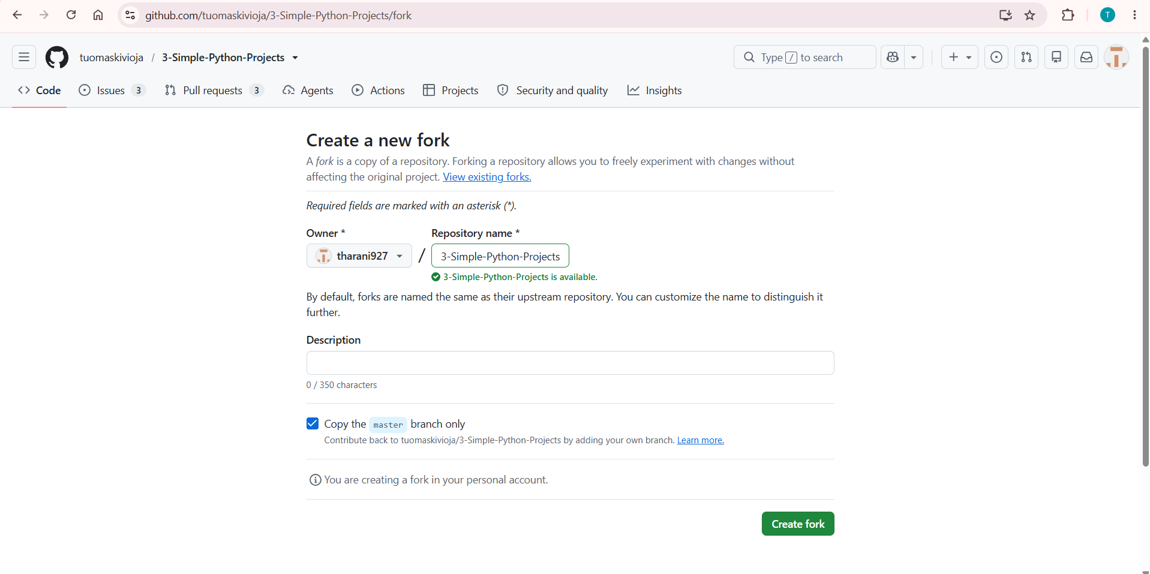
Step 2: Clone the Forked Repository
- Open Git Bash on the local machine.
- Navigate to the folder where the project needs to be stored.
- Copy the HTTPS URL of the forked repository from the Code button.
- Clone the repository using the git clone command.
git clone <forked_repository_url>
- Navigate into the cloned repository.
cd <repository_name>
- List the files to verify that the repository was cloned successfully.
Ls
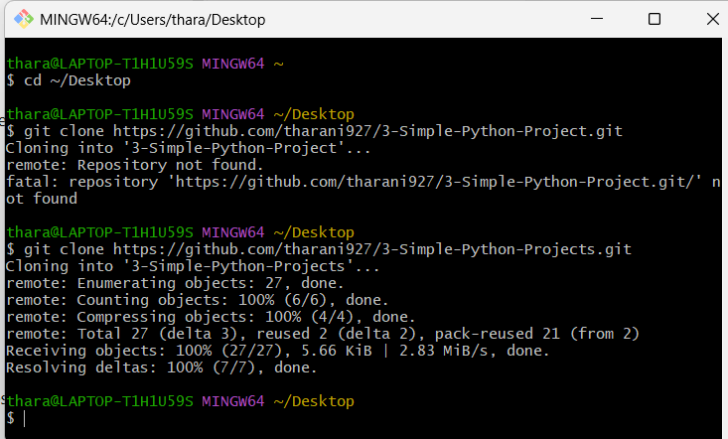
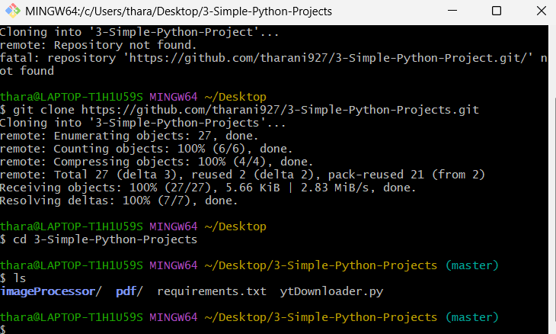
Step 3: Create a Feature Branch
- Create a separate branch for implementing the new feature.
- Switch to the newly created branch.
git checkout -b feature-update
- Verify that the feature branch is active.
git branch
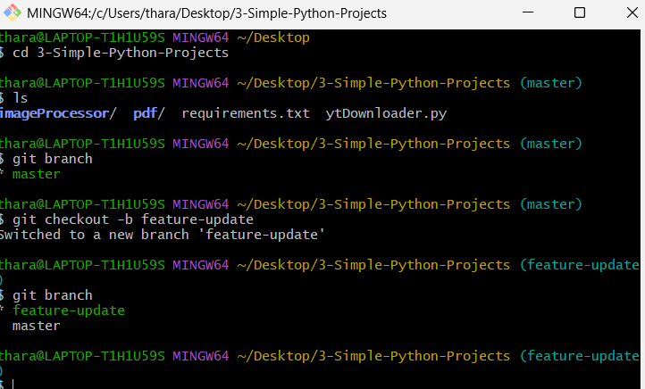
Step 4: Implement the Feature
- Open the project in Visual Studio Code or another code editor.
code .
- Select the appropriate project file.
- Add or modify the required feature without changing unrelated parts of the project.
- Save all changes.
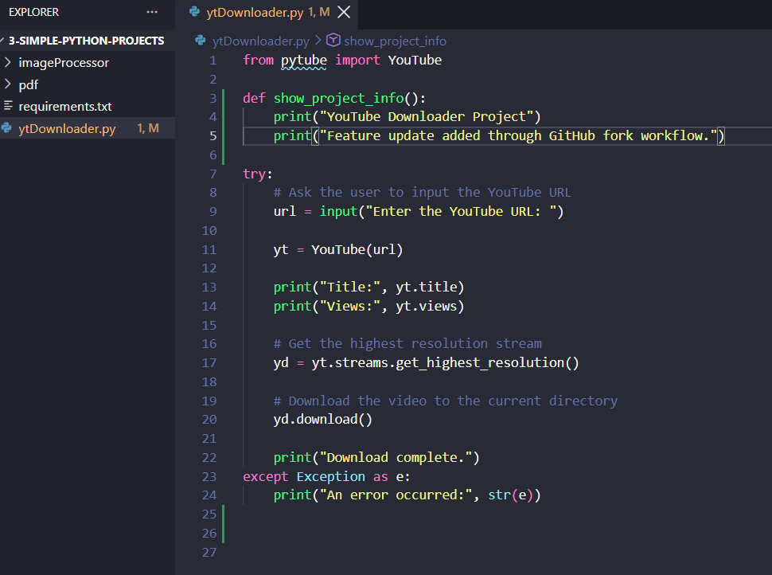
Step 5: Verify the Changes
- Return to Git Bash.
- Check the repository status.
git status
- Verify that the modified or newly created files are displayed.
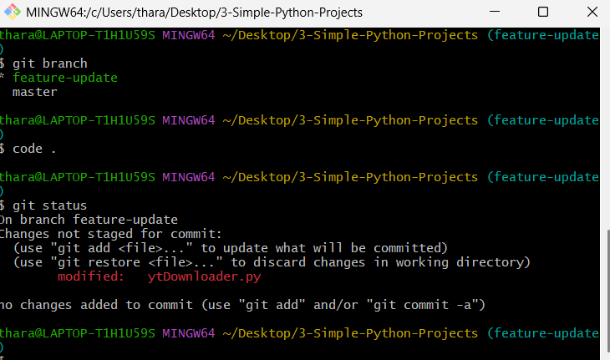
Step 6: Stage and Commit the Changes
- Add the modified files to the staging area.
git add .
- Commit the changes with a meaningful commit message.
git commit -m "Added new feature"
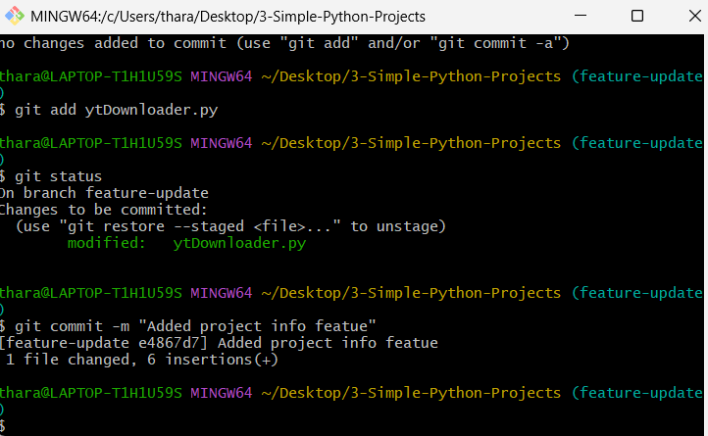
Step 7: Push the Feature Branch
- Push the feature branch to your forked GitHub repository.
git push -u origin feature-update
- Verify that the feature-update branch is available in your forked repository.
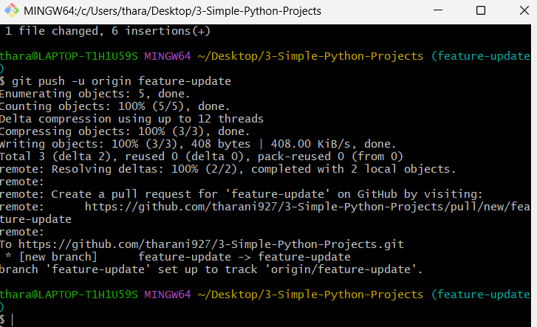
Step 8: Create a Pull Request
- Open your forked repository on GitHub.
- Click Compare & pull request or open Pull requests → New pull request.
- Set the original repository as the base repository.
- Select the main branch as the base branch.
- Select your forked repository and feature-update as the compare branch.
- Enter a suitable title and description for the pull request.
- Click Create pull request.
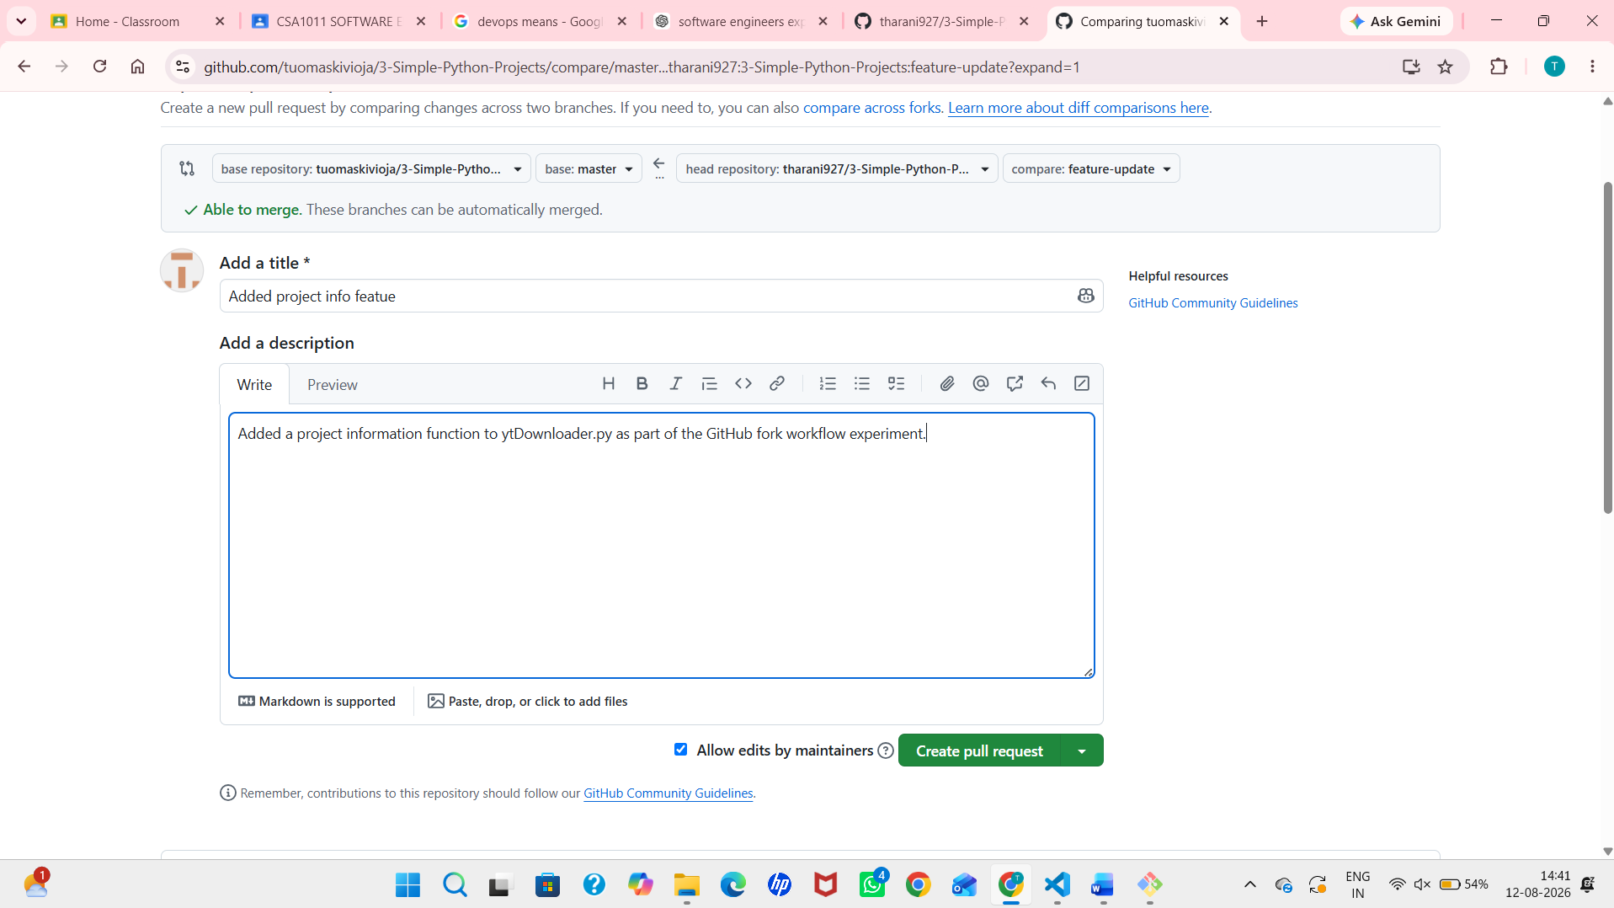
Step 9: Verify the Pull Request
- Open the Pull Request page.
- Verify that the feature changes are displayed correctly.
- Check that the Pull Request is directed from your fork to the original repository.
- Submit the Pull Request for review.
